28.83: a) The magnetic force per unit length between two parallel, long wires is:
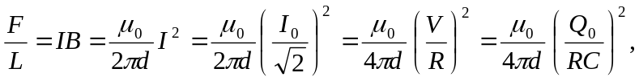
where 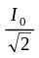 is the rms current over the short discharge time.
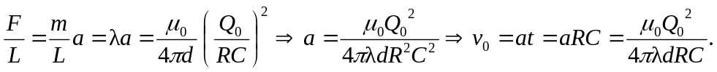

b)
c) Height that the wire reaches above the original height:
